eBooking Appointment System

PORJECT SCOPE

The application has three (3) Users;

1. System Admin.
2. Doctors
3. Patients.

The following are the functional requirements determination of the application;

➢The system allows the (**System Admin**) to add doctor.

➢The system allows the (**System Admin**) to edit doctor profile.

➢The system allows the (**System Admin**) to *delete doctor*.

➢The system allows the (**System Admin**) *to schedule new doctors sessions and remove sessions*.

➢The system allows the (**System Admin**) *to view patients details*.

➢The system allows the (**System Admin**) to *view booking of patients.*

Continuation:

➢The system allows the (**Doctor**) to *view their booking appointment*.

➢The system allows the (**Doctor**) to *view their scheduled sessions*.

➢The system allows the (**Doctor**) *to view details of patients*.   
  
➢The system allows the (**Doctor**) *to edit their info*.

➢The system allows the (**Doctor**) to *delete their account*.  
  
➢The system allows the (**Patient**) *to create an account*.

➢The system allows the (**Patient**) to *book an appointment online*.

➢The system allows the (**Patient**) *to view their booking appointment*.   
  
➢The system allows the (**Patient**) *to edit their info*.

➢The system allows the (**Patient**) to *delete their account*.

## USER ROLES

### SYSTEM ADMIN

Login details for System Admin: Email : admin@edoc.com

Password : 123

### DOCTOR

Login details for Doctor:  
 Email : doctor@edoc.com

Password : 123

### PATIENT

Login details for Patient:  
 Email : patient@edoc.com

Password : 123

#### USER LOGIN PAGE

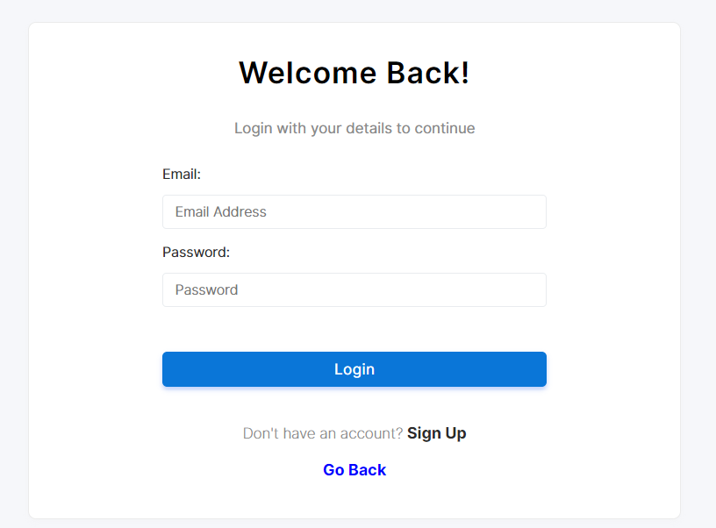

#### SYSTEM ADMIN DASHBOARD

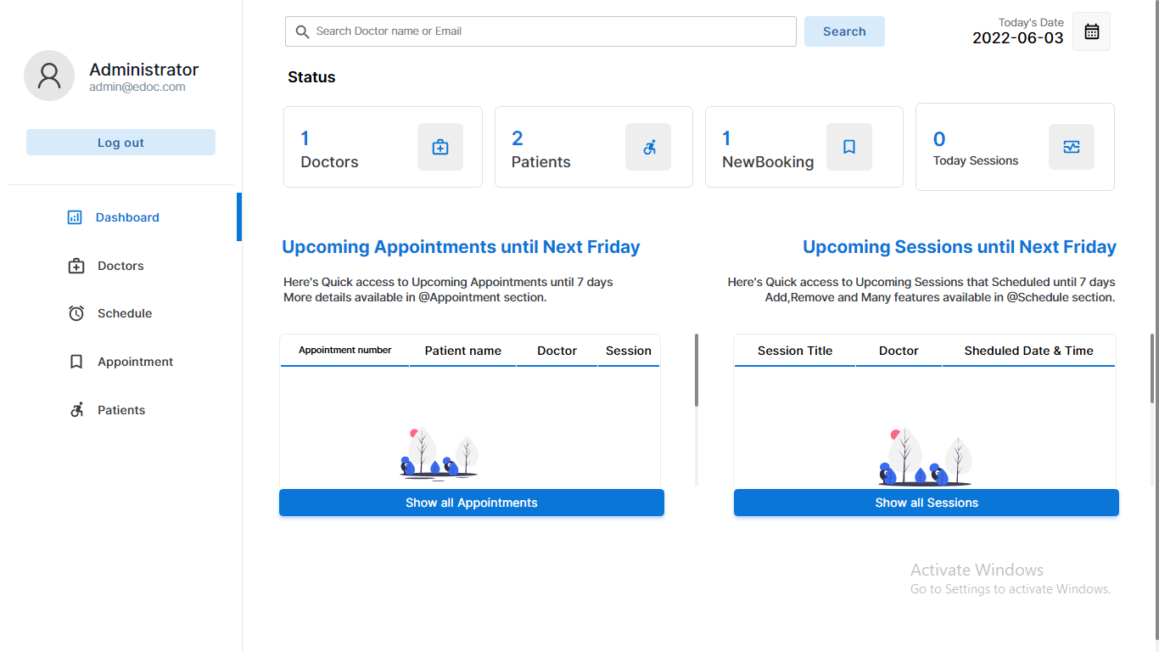

#### ADD A NEW DOCTOR

How to add a new Doctor;  
Go to admin -> Doctors -> Add New

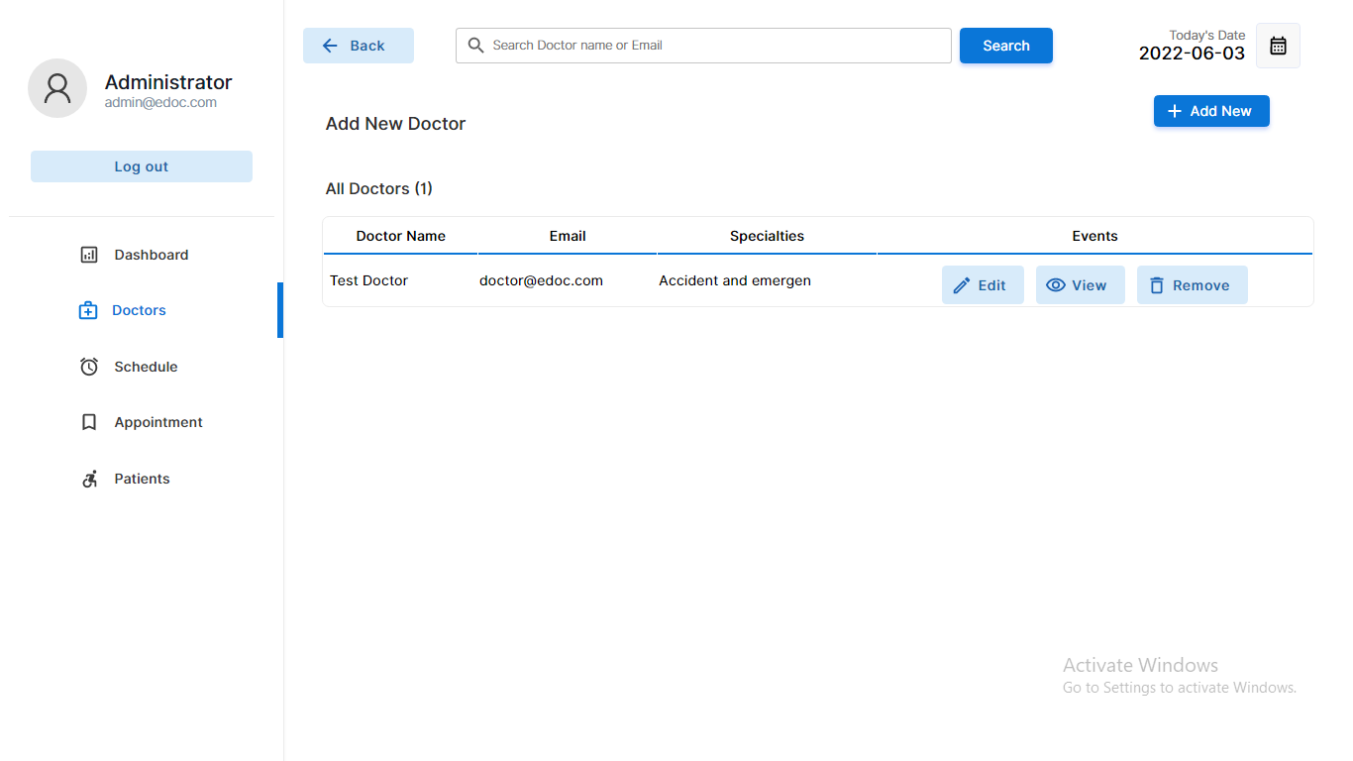

#### ADD A SCHEDULE

How to add a new Schedule;  
Go to admin -> Schedule -> Add a Session

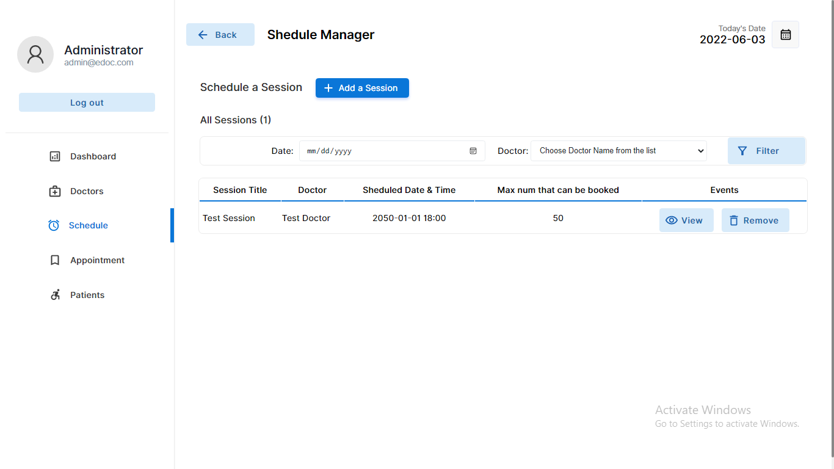

#### PATIENT DASHBOARD

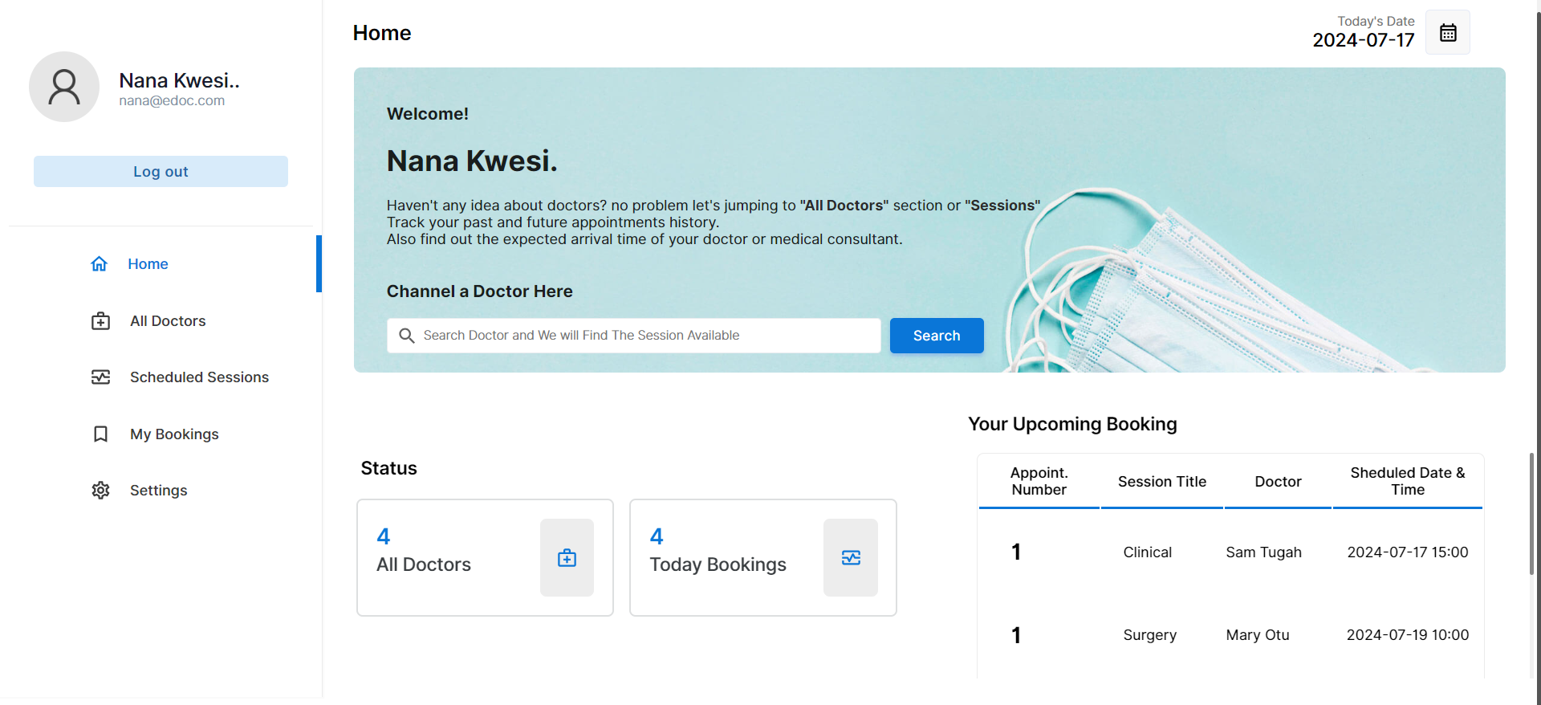

#### PATIENT SCHEDULED SESSIONS

How to book an appointment;  
Go to patient -> Scheduled Sessions -> Book Now

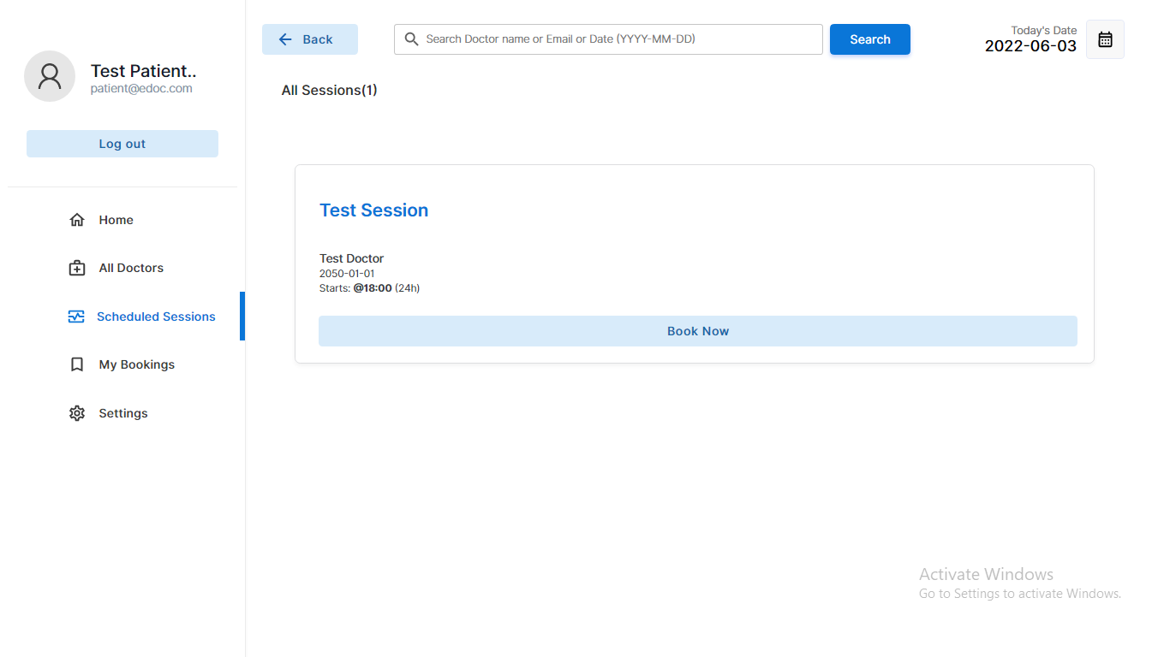

#### CANCEL AN APPOINTMENT BOOKING

How to cancel an appointment booking;  
Go to patient -> My Bookings -> Cancel Booking

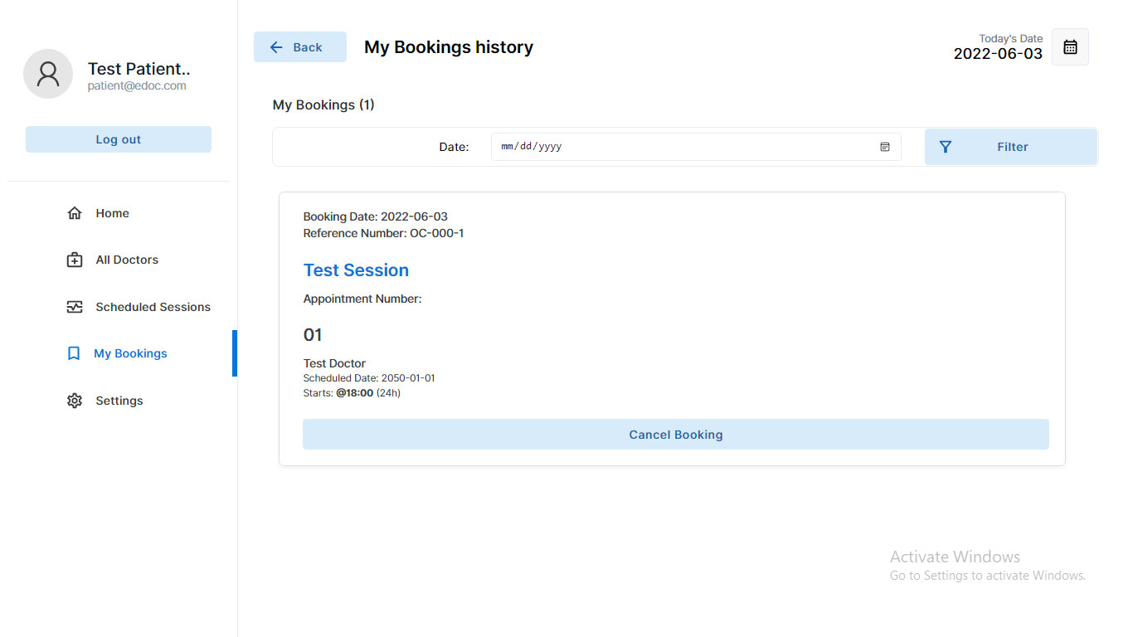

#### DOCTOR DASHBOARD

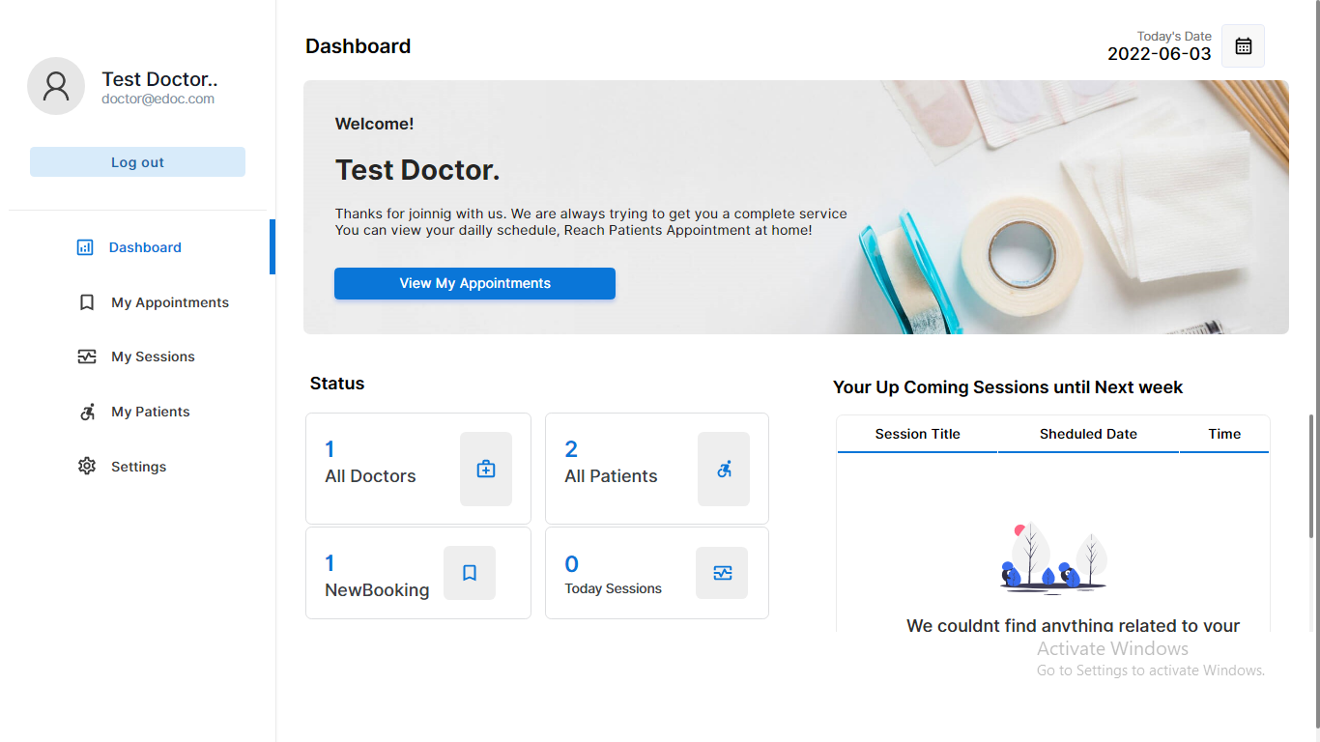

#### MANAGE ACCOUNTS

How to manage account profile;

Go to doctor -> Settings

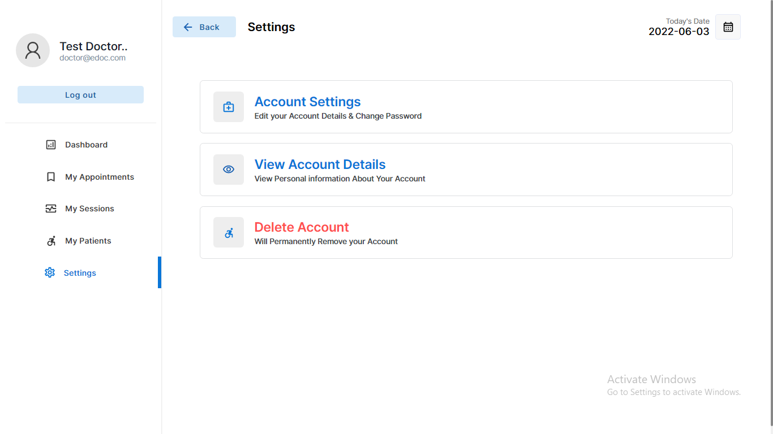

#### GET STARTED

1. Open your XAMPP Control Panel and start Apache and MySQL.
2. Extract the downloaded source code zip file
3. Copy the extracted source code folder and paste it into the XAMPP's "htdocs" directory
4. Browse the PHPMyAdmin in a browser i.e. <http://localhost/phpmyadmin>
5. Create a new database naming edoc
6. Import the provided SQL file. The file is known as DATABASE Edoc.sql located inside the source code root folder
7. Browse the Doctor's Appointment Systsem in a browser ie. [http://localhost/ doctor-appointment-system /](http://localhost/%20doctor-appointment-system%20/)